Possessive Pronouns

🔹 What Are Possessive Pronouns?
# Source: AI Source: Provided by: [Data Path: Persons Table -> ID Column: 1, Name_En Column: Motasem Essam] -> From: [Chatgpt (GPT-4-turbo)] on [7/27/2025]
Possessive pronouns are pronouns that show ownership or possession — they tell us who something belongs to.

✅ List of Possessive Pronouns
# Source: AI Source: Provided by: [Data Path: Persons Table -> ID Column: 1, Name_En Column: Motasem Essam] -> From: [Chatgpt (GPT-4-turbo)] on [7/27/2025]
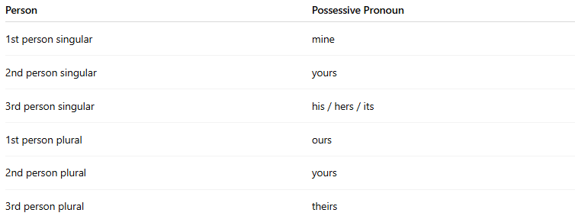
Person | Possessive Pronoun
1st person singular | mine
2nd person singular | yours
3rd person singular | his / hers / its
1st person plural | ours
2nd person plural | yours
3rd person plural | theirs
🔸 These pronouns stand alone — they are not followed by a noun.

📚 Examples in Sentences
# Source: AI Source: Provided by: [Data Path: Persons Table -> ID Column: 1, Name_En Column: Motasem Essam] -> From: [Chatgpt (GPT-4-turbo)] on [7/27/2025]
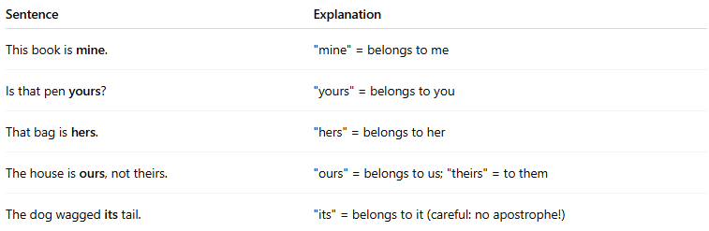
Sentence | Explanation
This book is mine. | "mine" = belongs to me
Is that pen yours? | "yours" = belongs to you
That bag is hers. | "hers" = belongs to her
The house is ours, not theirs. | "ours" = belongs to us; "theirs" = to them
The dog wagged its tail. | "its" = belongs to it (careful: no apostrophe!)

⚠️ Not the Same As Possessive Adjectives
# Source: AI Source: Provided by: [Data Path: Persons Table -> ID Column: 1, Name_En Column: Motasem Essam] -> From: [Chatgpt (GPT-4-turbo)] on [7/27/2025]
Possessive Adjective | Followed by a Noun | Example: my book
Possessive Pronoun | Stands Alone | Example: This book is mine

✏️ Summary:
# Source: AI Source: Provided by: [Data Path: Persons Table -> ID Column: 1, Name_En Column: Motasem Essam] -> From: [Chatgpt (GPT-4-turbo)] on [7/27/2025]
- Possessive Pronouns = mine, yours, his, hers, its, ours, theirs
- They replace a noun to show possession
- They do NOT come before a noun

